PRACTICAL WORKSHEET – EXPERIMENT 2
Experiment Title
Student Data Analysis Using Aggregate Functions in SQL

1. Aim of the Session
The aim of this practical session is to design and implement a database table to store student details and to analyze the data using SQL aggregate functions such as COUNT, AVG, SUM, MIN, and MAX along with GROUP BY, HAVING, and ORDER BY clauses.

2. Objective of the Session
After completing this practical, the learner will be able to:
- Understand the use of aggregate functions in SQL
- Apply GROUP BY and HAVING clauses for grouped data analysis
- Sort query results using ORDER BY
- Analyze student data city-wise
- Gain hands-on experience with Oracle SQL queries

3. Practical / Experiment Steps
- Create a Students table with appropriate attributes.
- Insert sample student records into the table.
- Count the number of students in each city.
- Sort cities based on student count.
- Find cities having at least a specific number of students.
- Calculate average, total, minimum, and maximum marks city-wise.

4. Procedure of the Practical
(i) Start the system and log in to the computer.
(ii) Open Oracle Live SQL / SQL*Plus.
(iii) Drop the existing Students table if it already exists.
(iv) Create the Students table using DDL commands.
(v) Insert student records using INSERT statements.
(vi) Execute SELECT queries using GROUP BY, HAVING, and ORDER BY clauses.
(vii) Verify the output generated after execution.
(viii) Save the work and capture screenshots of execution and results.

5. I/O Analysis (Input / Output Analysis)
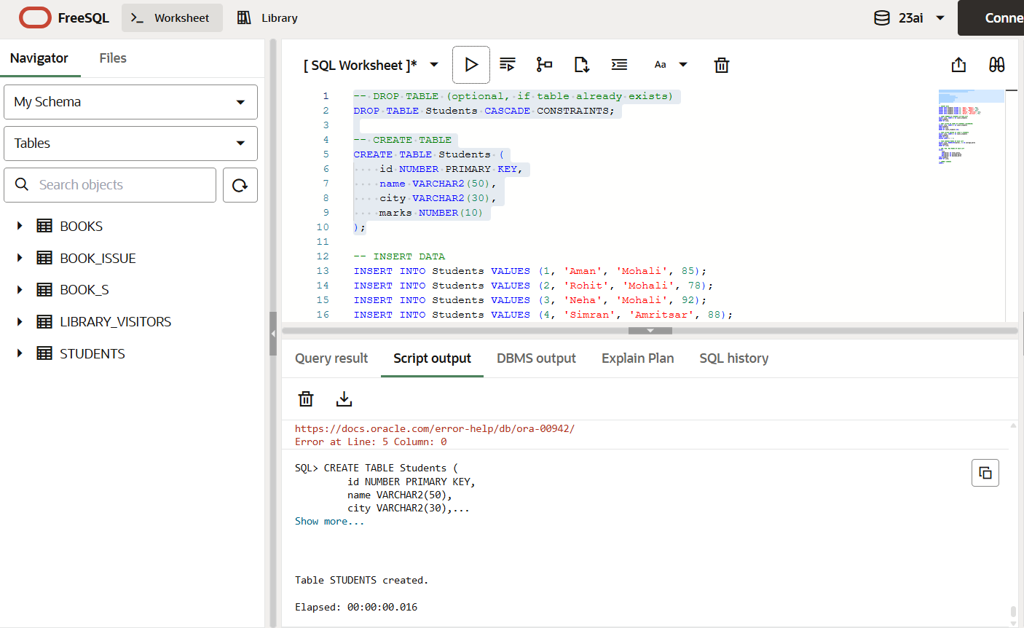

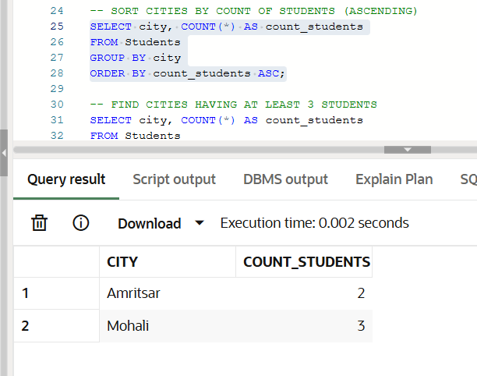

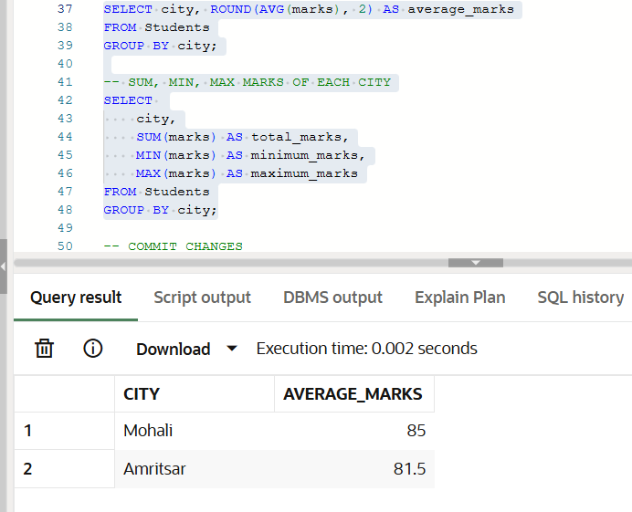
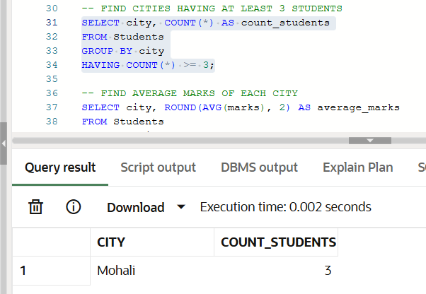

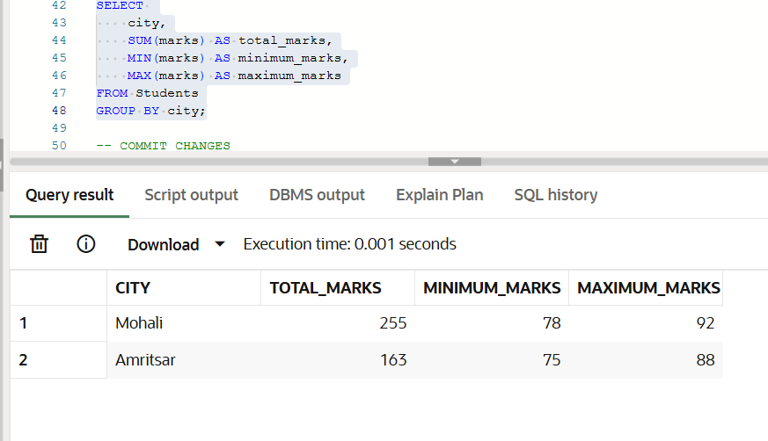

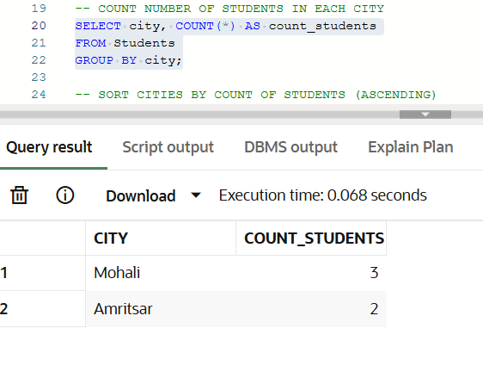

Input
- SQL commands to create the Students table
- INSERT statements for student data
- SELECT queries using aggregate functions
Output
- City-wise count of students
- Sorted city list based on number of students
- Cities satisfying HAVING condition
- Average, total, minimum, and maximum marks per city
(Screenshots attached showing execution and output)

6. Learning Outcome
From this practical, the student learned:
- Usage of SQL aggregate functions
- Data grouping and filtering using GROUP BY and HAVING
- Sorting query results using ORDER BY
- Practical data analysis using SQL
- Improved understanding of relational data processing

